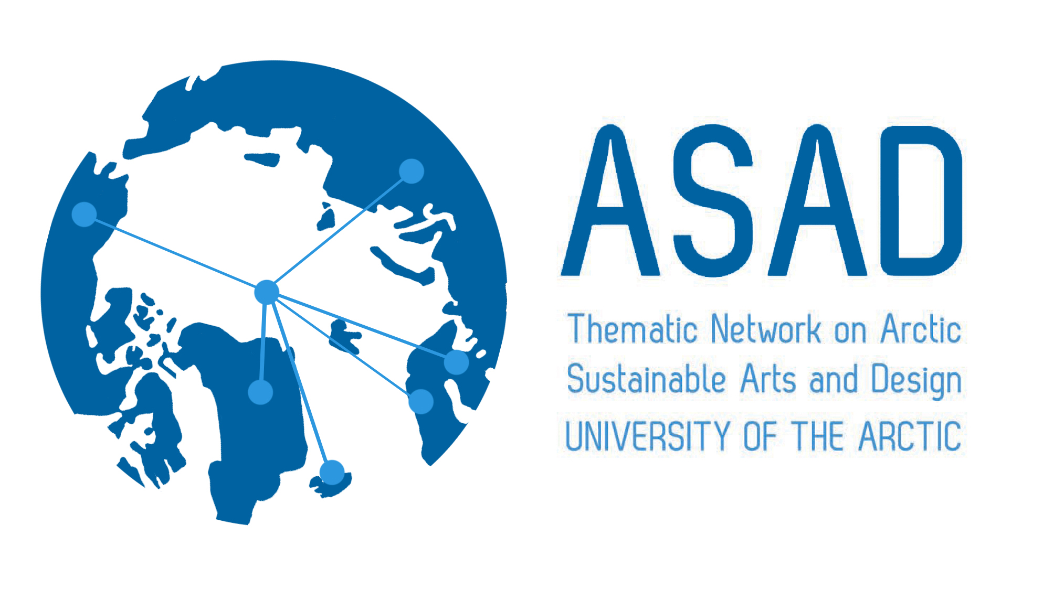
www.asadnetwork.org

RELATE NORTH: Culture, Community and Communication
CALL FOR CONTRIBUTIONS

This will be the third book published in the Relate North series. The first edition was published in 2014, Relate North: Engagement, Art and Representation and the second, Relate North: Art, Heritage and Identity in 2015. The series is dedicated to the exploration and sharing of contemporary practices in arts based research and knowledge exchange in the fields of arts, design and visual culture education. Each volume consists of peer-reviewed chapters mainly in the form of research reports and critical essays, but may also include invited articles, interviews or image-text features (visual essays). The Relate North series will be of interest to academic researchers, artists, designers and art educators, practice-based researchers and those with a general interest in Northern and Arctic issues. This call is for contributions to the third issue, scheduled for late 2016.
Relate North is an English language, peer-reviewed publication. The terms ‘arts’ and ‘design’ should be interpreted broadly to include, for example, crafts, indigenous making, media, product or service design.
Chapters and visual essays are sought for the third issue of Relate North, which focus on the general topic of ‘sustainable arts and design’ and address issues of culture, community or communication.

The editors invite submissions of a synopsis of the proposed contribution (no more than 500 words, or 100 words for a visual essay) by 31 January 2016; it is envisaged that completed drafts of articles will be submitted by the end of June 2016.

Please see author guidelines below.

Emphasis is placed on contributions that critically reflect on:
- Northern and Arctic perspectives on arts and design
- Issues of sustainability in the fields of arts, design, visual culture and craft education.
- Context-sensitive research methods and contemporary arts, crafts & design practices in the Arctic and Northern regions
- The relationship between education, design and contemporary visual arts
Contributions are particularly welcome that:
- Focus on Northern, Arctic issues in the field of arts, design and visual culture
- Advance understanding and improve arts, design and visual culture education particularly amongst people living in Northern and Arctic areas.
- Propose original ways of rethinking the status of contemporary arts, design, craft and new practices in art education in the Northern and Arctic context

Editors: Timo Jokela & Glen Coutts, University of Lapland

Submissions: Synopsis should be emailed to: glen.coutts@ulapland.fi
and: timo.jokela@ulapland.fi

Deadline for synopsis: Sunday 31 January 2016

Authors notified of decisions: Friday 12 February 2016

Complete draft: Friday 29 April, 2016

Double blind peer review period 30 April - 30 May 2016

Final decisions Tuesday 31 May 2016

Publication November/ December 2016

The editors will review the synopses and invite chapters to the next stage (peer review).

Review policy Double blind review

Guidelines for authors (for full contributions).

Authors should bear in mind the overall themes of the issue, Sustainable Arts and Design in the Arctic and the North when writing.

Chapters should be 5000 (+/- 10%) words. If authors are considering submitting a visual essay, please consult the editors with a proposal or synopsis.

Relate North uses the APA author-date system of bibliographical referencing. References should be listed alphabetically at the end of the paper and must be adhere to APA conventions.

A short (maximum 80 words) author biographical note is also required. This should not be contained in the article, but can be sent in the same file.

Send text documents in Microsoft Word (.doc) format with low-resolution images embedded to show preferred position (if the article is accepted high resolution images will be required). Authors are responsible for copyright clearance of images.

Articles may include between 6 - 10 illustrations (images, tables, drawings etc.). Please prioritize all the illustrations with numbers. This will give us flexibility in working with the layout. The final images may be in TIFF, PNG or JPG format (300 dpi, 145mm/1740 pixel width). Title all the files with your full name.

Potential authors may want to consult the first or second issue:
Jokela, T., & Coutts, G. (Eds.). (2014). Relate North 2014: Engagement, Art and Representation. Rovaniemi: Lapland University Press.

Jokela, T., & Coutts, G. (Eds.). (2015). Relate North: Art, Heritage & Identity. Rovaniemi: Lapland University Press

If you have any questions, please contact:

Glen Coutts or Timo Jokela

glen.coutts@ulapland.fi or timo.jokela@ulapland.fi

